**Creating a maven project for an Android Application**

**Install the Maven Android plugin**

1. Run Eclipse and go to Help🡪Eclipse Marketplace…
2. Enter “m2e android” into the search and hit enter
3. Install *Android Configurator for M2E.*
4. Restart Eclipse when finished.

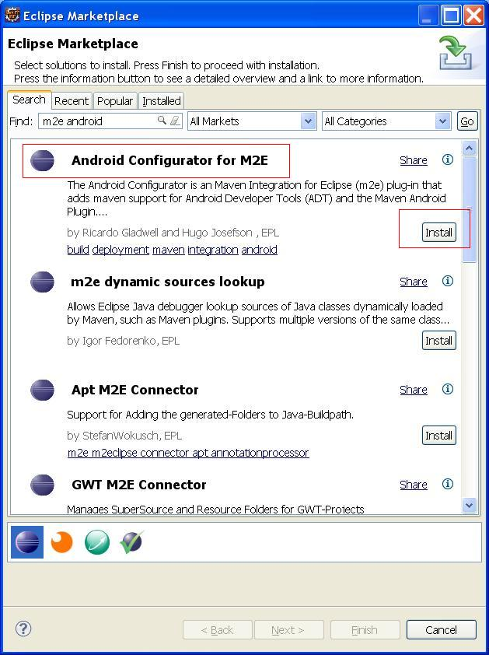

**Finish Setup for Android Configurator and install Android SDKs**

The Android Configurator for M2E eclipse plugin will allow you to select or install the Android SDKs you need on your system in order to develop this app. The next step is to allow this plugin to install the Android SDKs for you.

1. After Eclipse restarted it will prompt you for some initial preference that has something to do with the SDK location (can’t remember), just close the first small popup window.
2. Next the Android Development wizard will show. Fill it in as shown in the screen shot below. (You can use whatever Target Location you prefer)

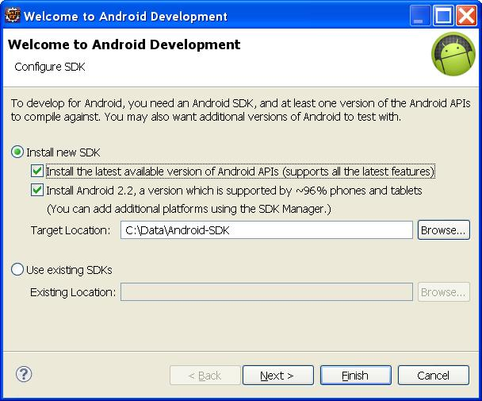

This might take a little while to download.

After you finish this wizard you will have the Android SDK installed and you should open the Target Location where the SDK is installed because you need to use the SDK Manger to install more functionality in order for the project to build properly.

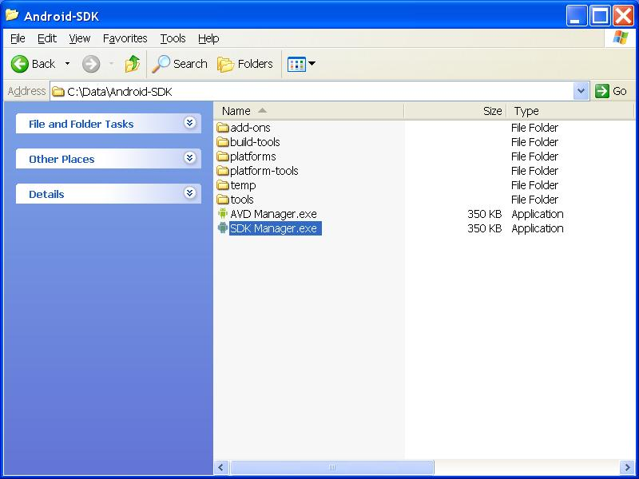

Inside of the SDK manager select the following two checkboxes for Android 4.3 (API 18), and Android SDK build tools 18.1.1. Click the Install packages button and install all of them. This will also take a while to download and install. When finished, restart eclipse.

**Project Setup**

1. File 🡪 New 🡪 Maven Project
2. Next
3. Click Add Archetype…
4. Enter the following info:

**Archetype Group Id:** de.akquinet.android.archetypes

**Archetype Artifact Id:** android-quickstart

**Archetype Version:** 1.0.10

1. Click OK and select the android-quickstart version 1.0.10 from the list.
2. Click Next
3. Enter your Group Id 🡪 This works as follows: If you have packages that will be like com.cirka.appname.view, com.cirka.appname.model, com.cirka.appname.control; Then the Group Id should be: com.cirka
4. Enter your Artifact Id 🡪 if your package naming strategy is the same as specified in #7 then enter appname as the Artifact Id.
5. Remove “foo” under package.
6. Click Finish.

**Running the app for the first time**

1. Open the java file: HelloAndroidActivity.java located in the src/main/java folder of the eartrainer project (it is in the com.lyra.eartrainer package)
2. Normally you would click the Play button to run the java file as a java application. However, we need to create a runtime configuration for this application. Click the Drop-down for the Play button in the toolbar and then click Run Configurations

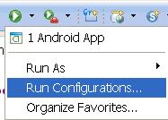

1. Name it “Android App” or whatever you want.
2. Click browse and select the eartrainer project for the “Project” field.

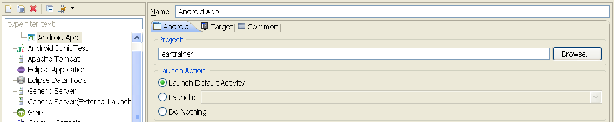

1. Select the “Target” tab and select the bottom radio option for “Automatically pick compatible device …”

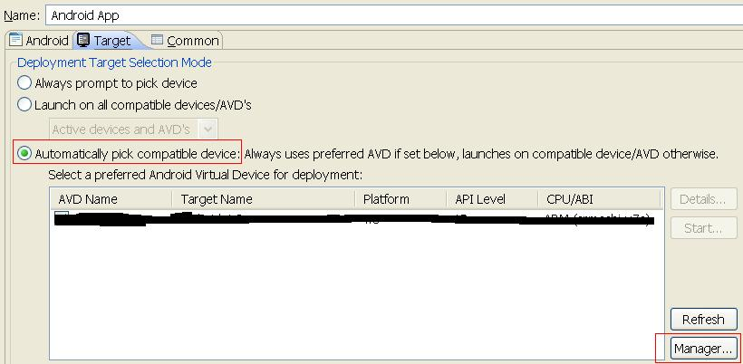

1. Click Manage.
2. Select the Device Definitions tab and select the top device in the list (nexus s)

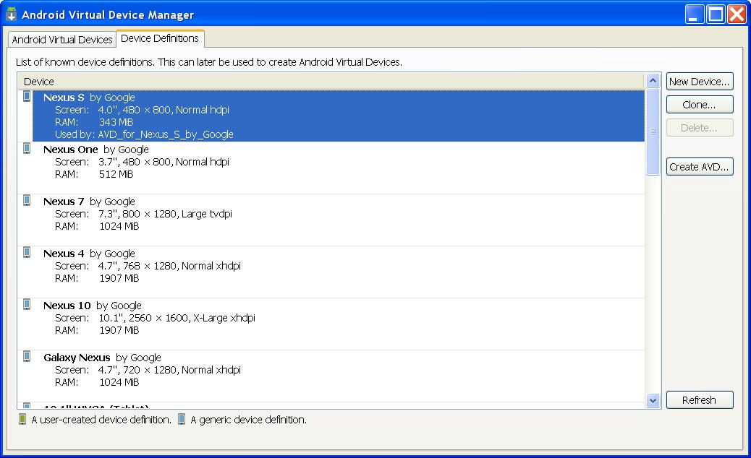

1. Click Create AVD
2. Fill it in as shown below

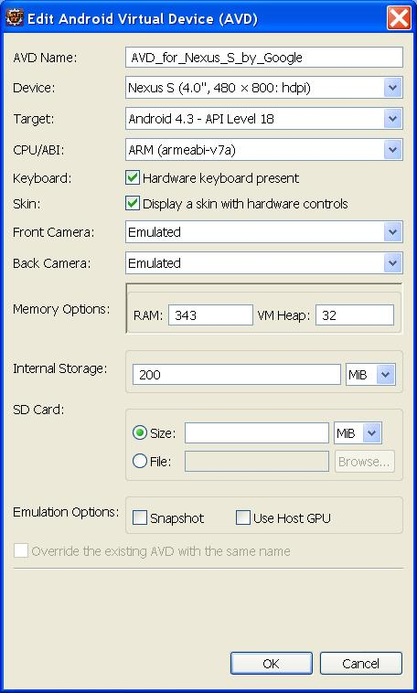

*Note: Make sure armeabi-v7a was selected for CPU/ABI. If you couldn’t select it then you need to re-open your Android SDK Manager and download the ARM EABI v7a under Android 4.3 (API 18).*

1. Click the “OK” button and
2. Select the device and click Start if you’d like to test it.
3. Make sure that the device is checked in the list. Click Apply.

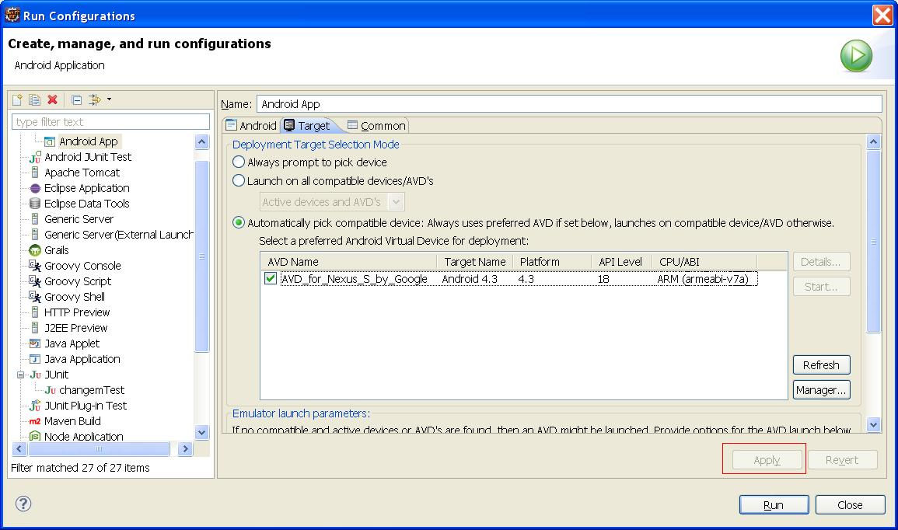

1. Select the “Common” tab.
2. Check the “Run” item in the *Display in favorites menu* list item and then click Apply.

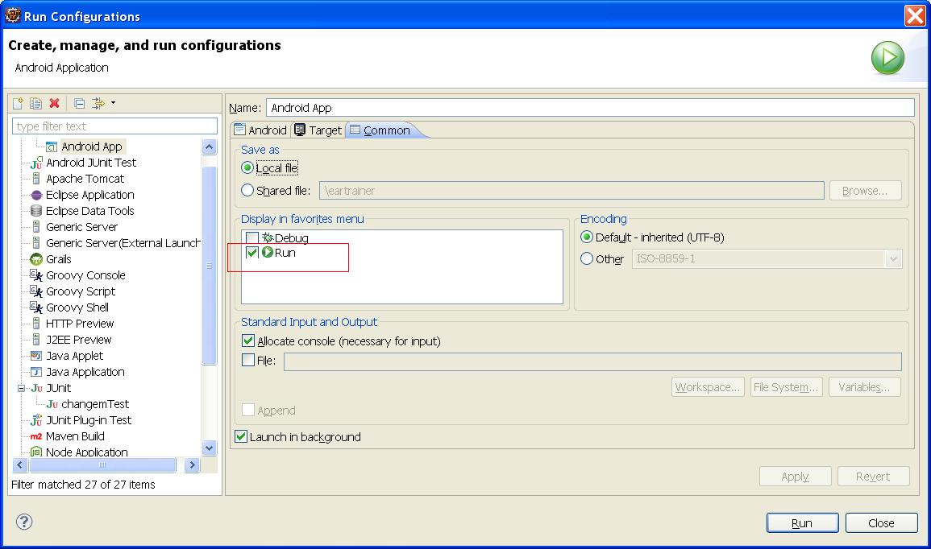

1. You should be able to run this application simply by clicking the play button in the toolbar.

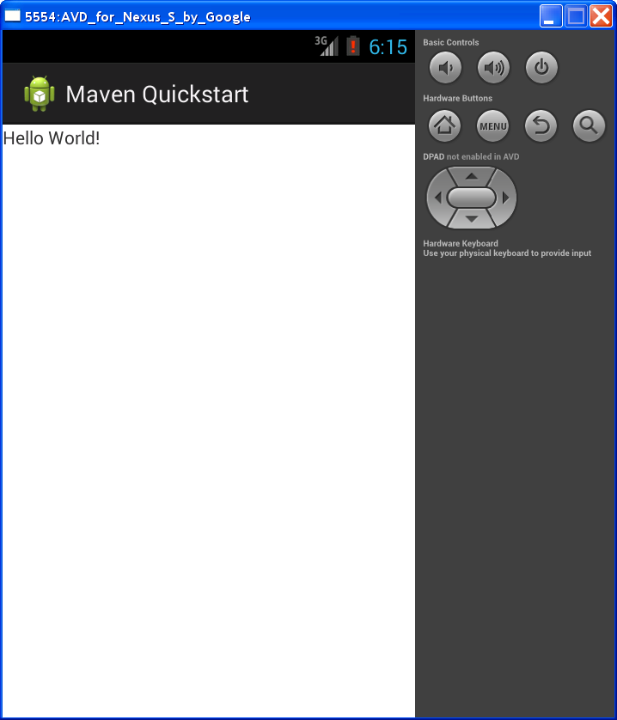

Assuming everything worked fine then you should see a window like this. It will first need to boot the android VM which takes a really long time. Eventually it will deploy the apk to the VM and then automatically run the app on the VM as shown above. You might need to click somewhere in the window or on the menu button in order to get it to show after it first loads.